**GOVERNMENT OF TELANGANA STATE**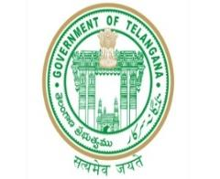

**TELANGANA TRIBAL WELFARE RESIDENTIAL DEGREE COLLEGE (GIRLS), MAHABUBABAD: MAHABUBABAD-DIST**

**E-Mail Id:ttwrdcgirls.mahabubabad@gmail.com Cell No: 7901097695.** 

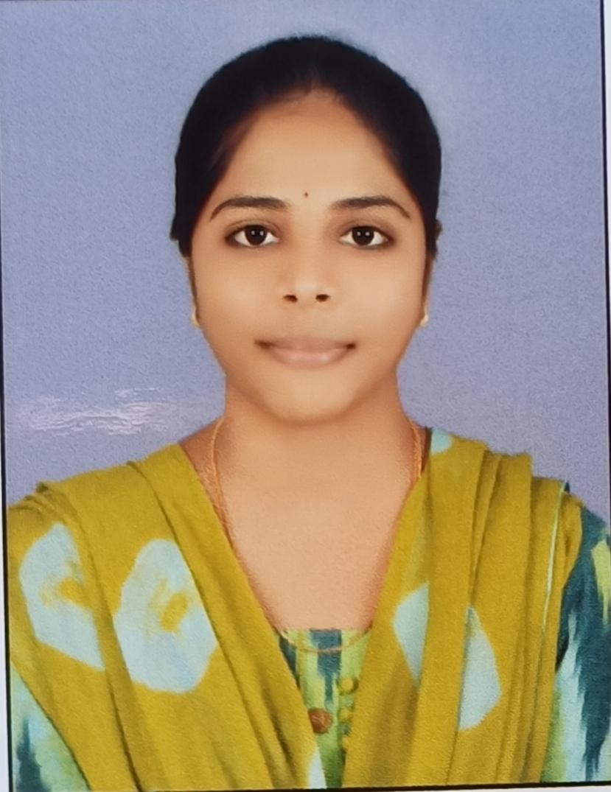

PROFILE

Name : Kaparaboina Kavya

Designation : Lecturer

Department : Statistics

Mail Id : kavyakaparaboina96@gmail.com

Date of Birth : 17-11-1997

Nationality : Indian

EDUCATIONAL QUALIFICATIONS

|  |  |  |  |  |  |
| --- | --- | --- | --- | --- | --- |
| S.No | Course | University | Year | Specialization | Marks/CGPA |
| 1. | M.Sc | Osmania University | 2020 | Applied statistics | 7.12 |

EXPERIENCE

|  |  |  |  |  |
| --- | --- | --- | --- | --- |
| S.No | Designation | College | Place | Duration |
| 1 | Lecture | DRS Degree college | Khammam | 1 year |
| 2 | Lecture | TTWRDC (G) | Mahabubabad | 2 years |